Chrome Dev Editor is a Chrome App itself, it is from Google, and it can be used to easily create, edit, and run a number of Chrome App variations.
First make sure that you have the Chrome Browser installed, and that it is the default browser. If you don't have it, install it from here: http://www.google.com/chrome/browser
Click the Download Chrome button.
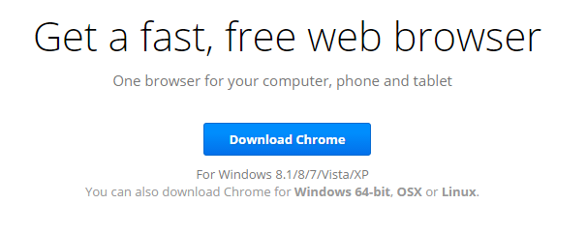

Open up the Chrome browser, and go to this address: https://chrome.google.com/webstore/category/apps
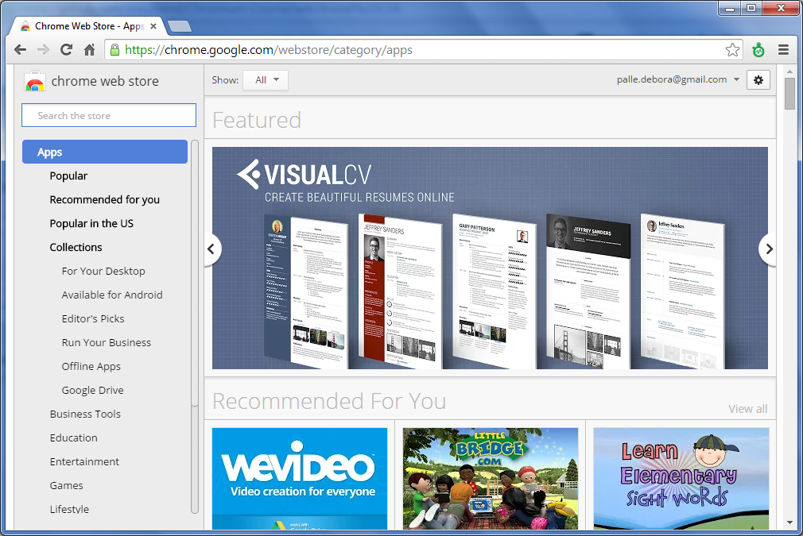

This is the Chrome Web Store. This is also the place where you, after finishing this class, will be able to put your own application for others to find, install, and enjoy.

Type chrome dev editor into the search box and press <Enter>
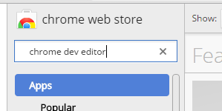

Now if necessary, filter the search results to be only Apps, By Google, and Free.
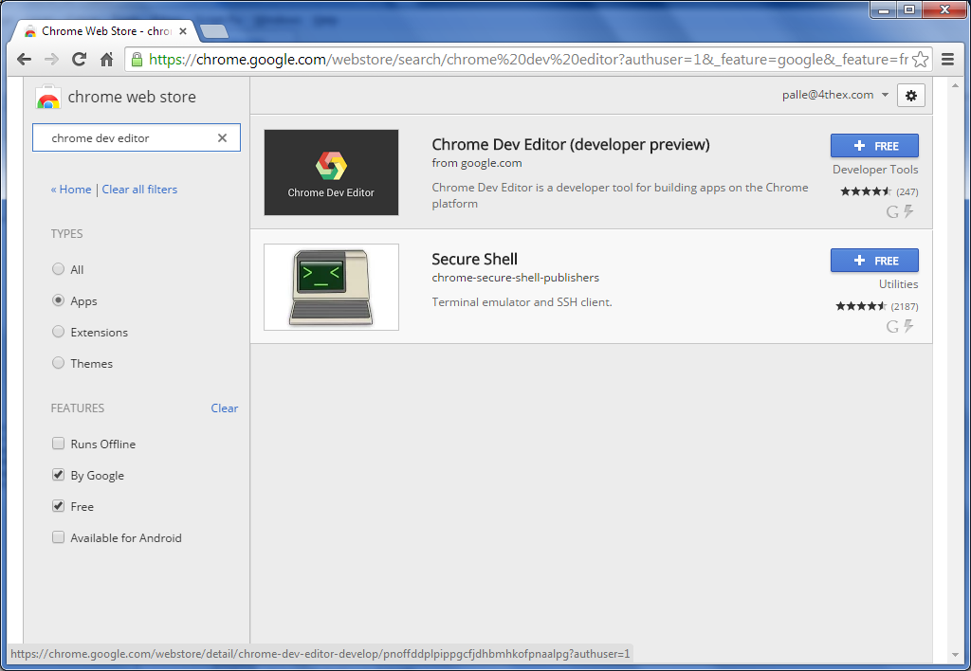

You should now see Chrome Dev Editor at the top of the search results.
Click on the + FREE button to the right.
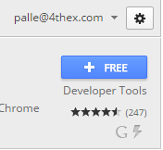

You will be prompted for accepting that the app gets certain permissions. It is OK, just go ahead and accept by clicking the Add button. This application is from Google, and if you didn't trust Google, you should probably not even have Chrome installed.
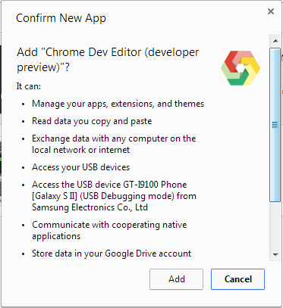

The icon will look like this for a minute while it is being installed:
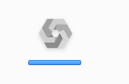

That's it! You have now installed Chrome Dev Editor. To start it, you can click on the Launch App button from the Chrome Web Store.
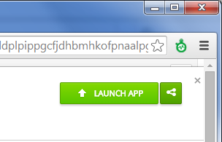

You can also launch it from the Chrome App Launcher.
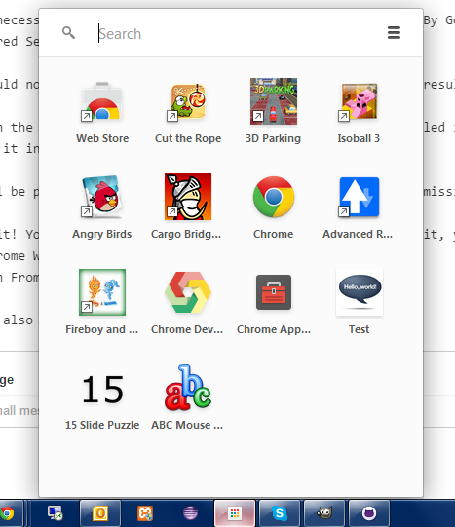

It is a new icon that has been pinned to your task bar.

Notice that the Chrome Dev Editor itself is a Chrome App, and it is a good example of what is possible to do in a Chrome App. It is a bit like a chicken-and-egg problem. If the tool to create Chrome Apps is a Chrome App, then what tool was used to create that? It turns out that you can create Chrome Apps pretty much using a simple text editor like Notepad or something, but it is just more painful.

Go ahead and create your first project. Click on the red plus icon in the bottom left area:
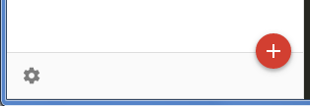

Since this is the first time you run the Chrome Dev Editor, you must specify the location on your local disk where you want your stuff stored.
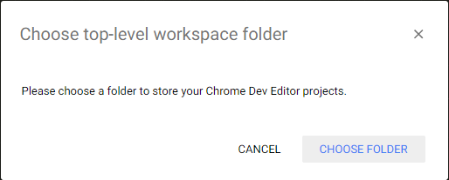

Click on the CHOOSE FOLDER link.
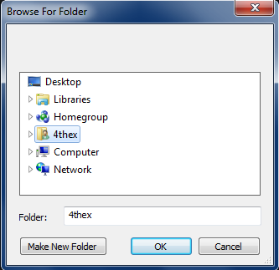

By default it will be your user profile, but you can choose any location you want, and make a new folder there if you like. I recommend my students to choose a location on a USB flash drive, because in that way they can bring their projects home and work on them there.

Give your first project a name such as MyFirstProject, and choose JavaScript web app as Project type
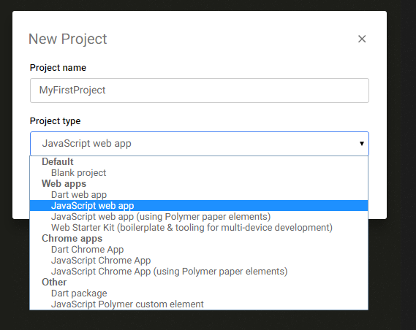

Notice how three files are created for you:
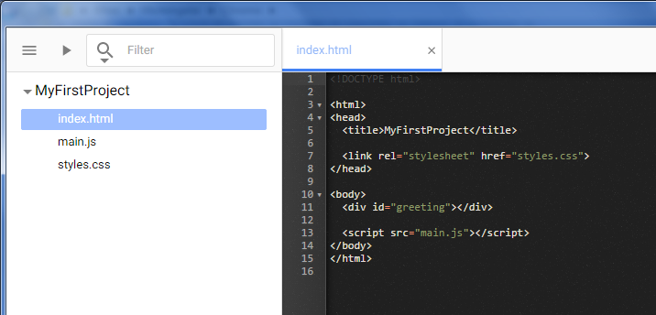

Make sure the index.html file is selected, and then click the run button; the triangle in the top left area. A Chrome browser tab will be created, and run your project:
